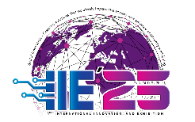
TITLE OF PROJECT/INNOVATION
TITLE
Team Leader
Member 1, Member 2, Member 3
Institution, City, Country
Email address
Student Advisor
Institution, City, Country
Email address
Abstract
All submissions must include a concise and factual abstract written. Abstract should be a single paragraph consisting of 250-500 words, without subheadings, indentation or references
please include information in the following sections, as relevant introduction, objectives, problem statement, significance, efficiency, replicability, effectiveness and implementation potential.
Abstracts must be written in Malay/English.

Keywords: single, paragraph, summarizes, words indentation [Minimum 3 words - Maximum 6 words]

